EPAM University Programs

DevOps external course

Module 4 Linux & Bash Essentials

TASK 4.6

1. User management. Here we suppose there are at least two users, namely, root and guest.   
(i) Create a new user user

groupadd user

useradd -g user -s /bin/bash -d /home/user -m user

passwd user

id user

ls -ld /home/user

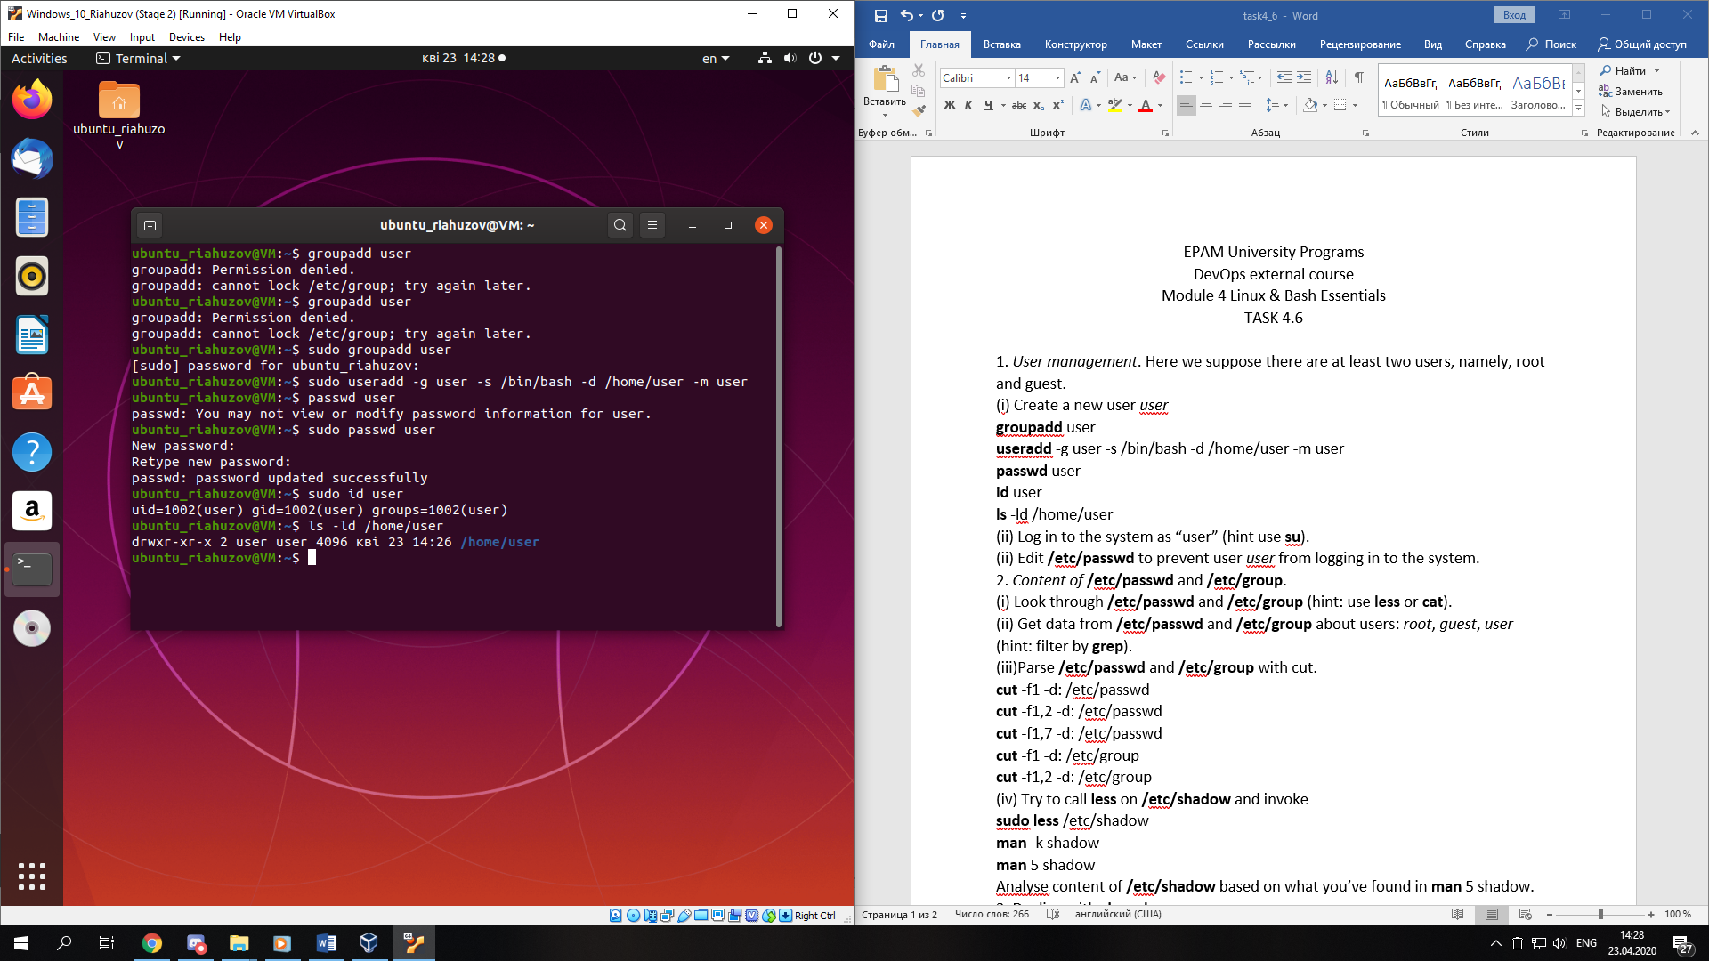

(ii) Log in to the system as “user” (hint use su).

sud

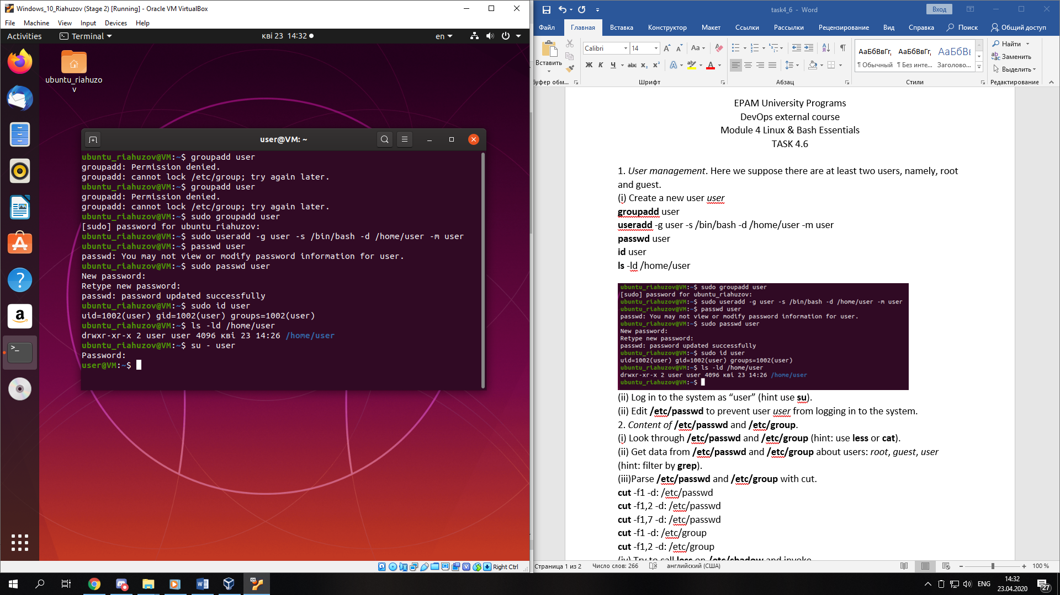

(ii) Edit /etc/passwd to prevent user user from logging in to the system.

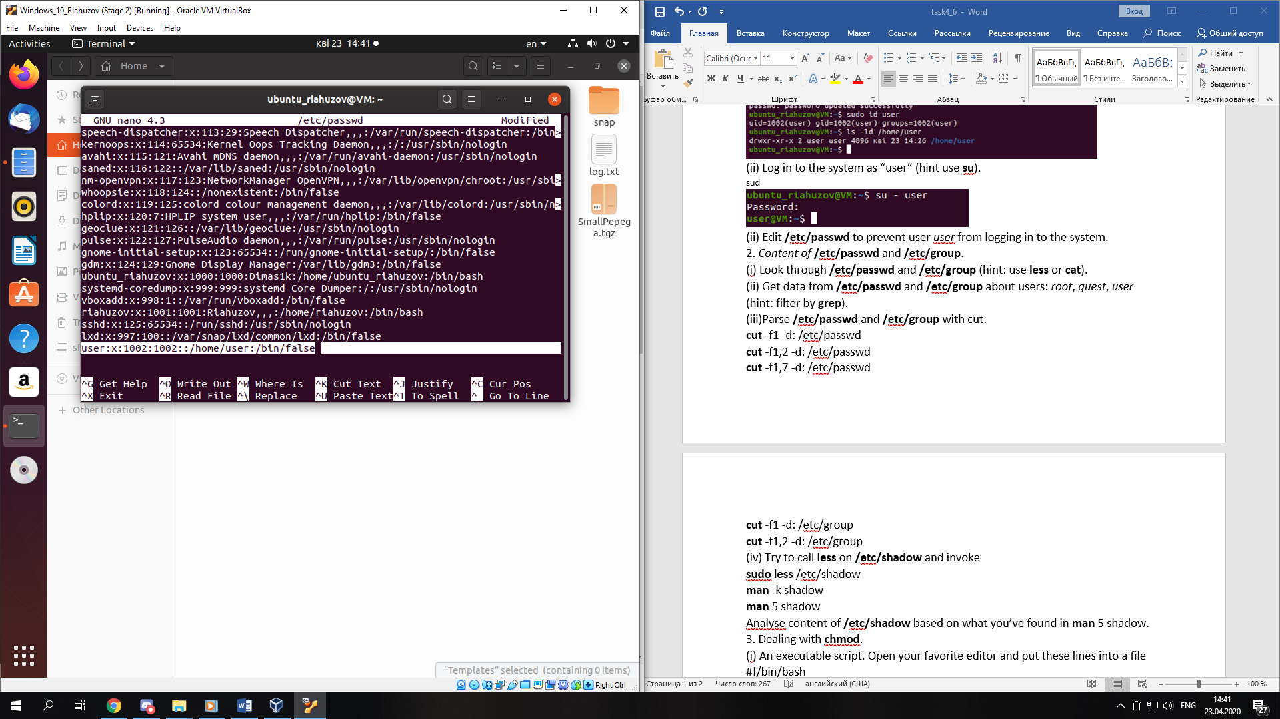

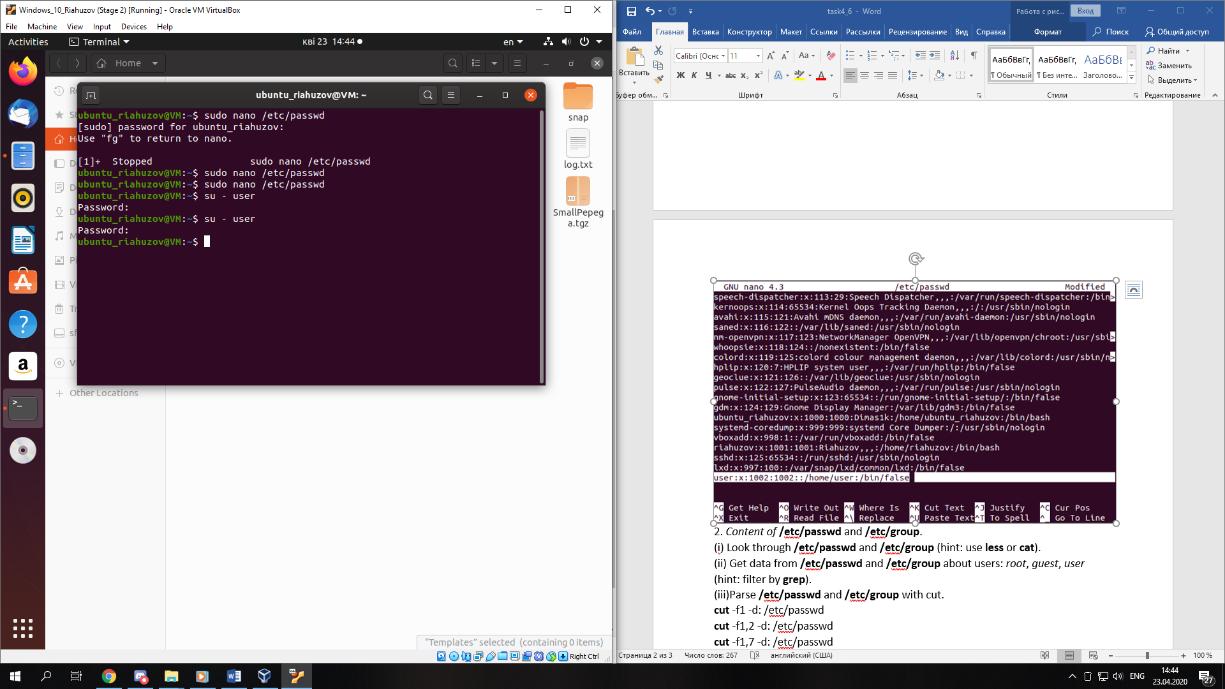cat

2. Content of /etc/passwd and /etc/group.

(i) Look through /etc/passwd and /etc/group (hint: use less or cat).

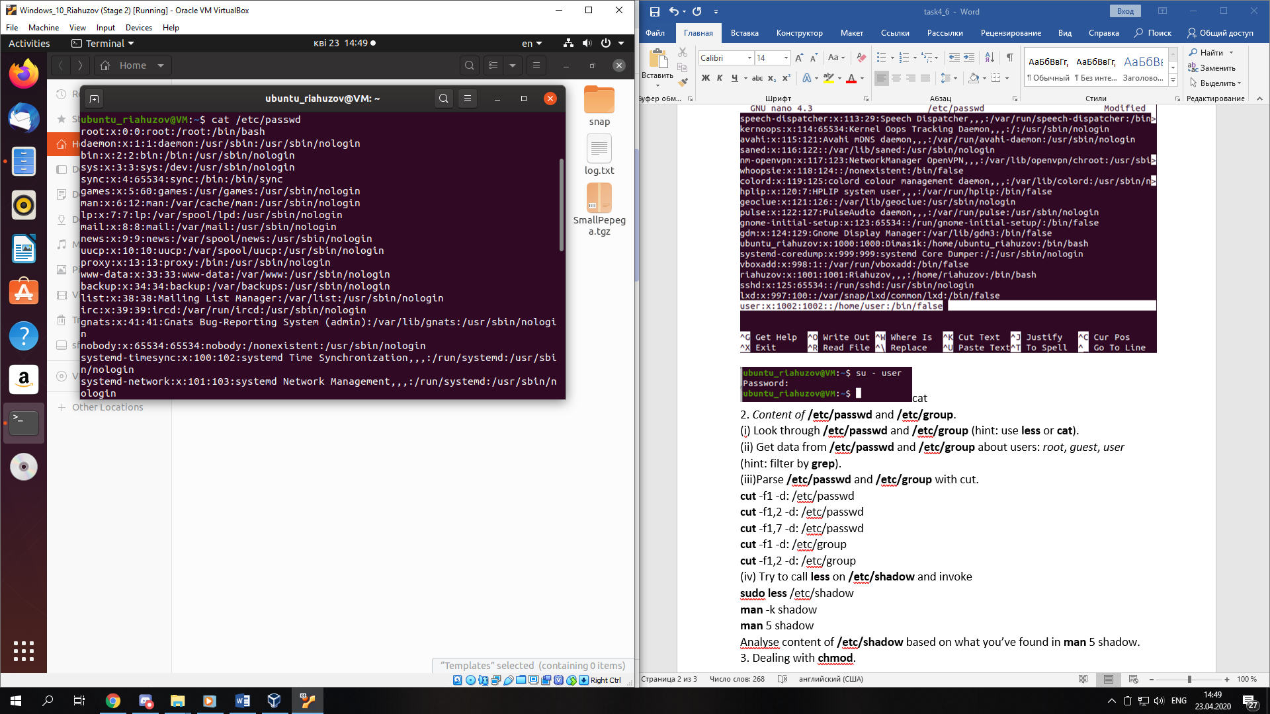

g

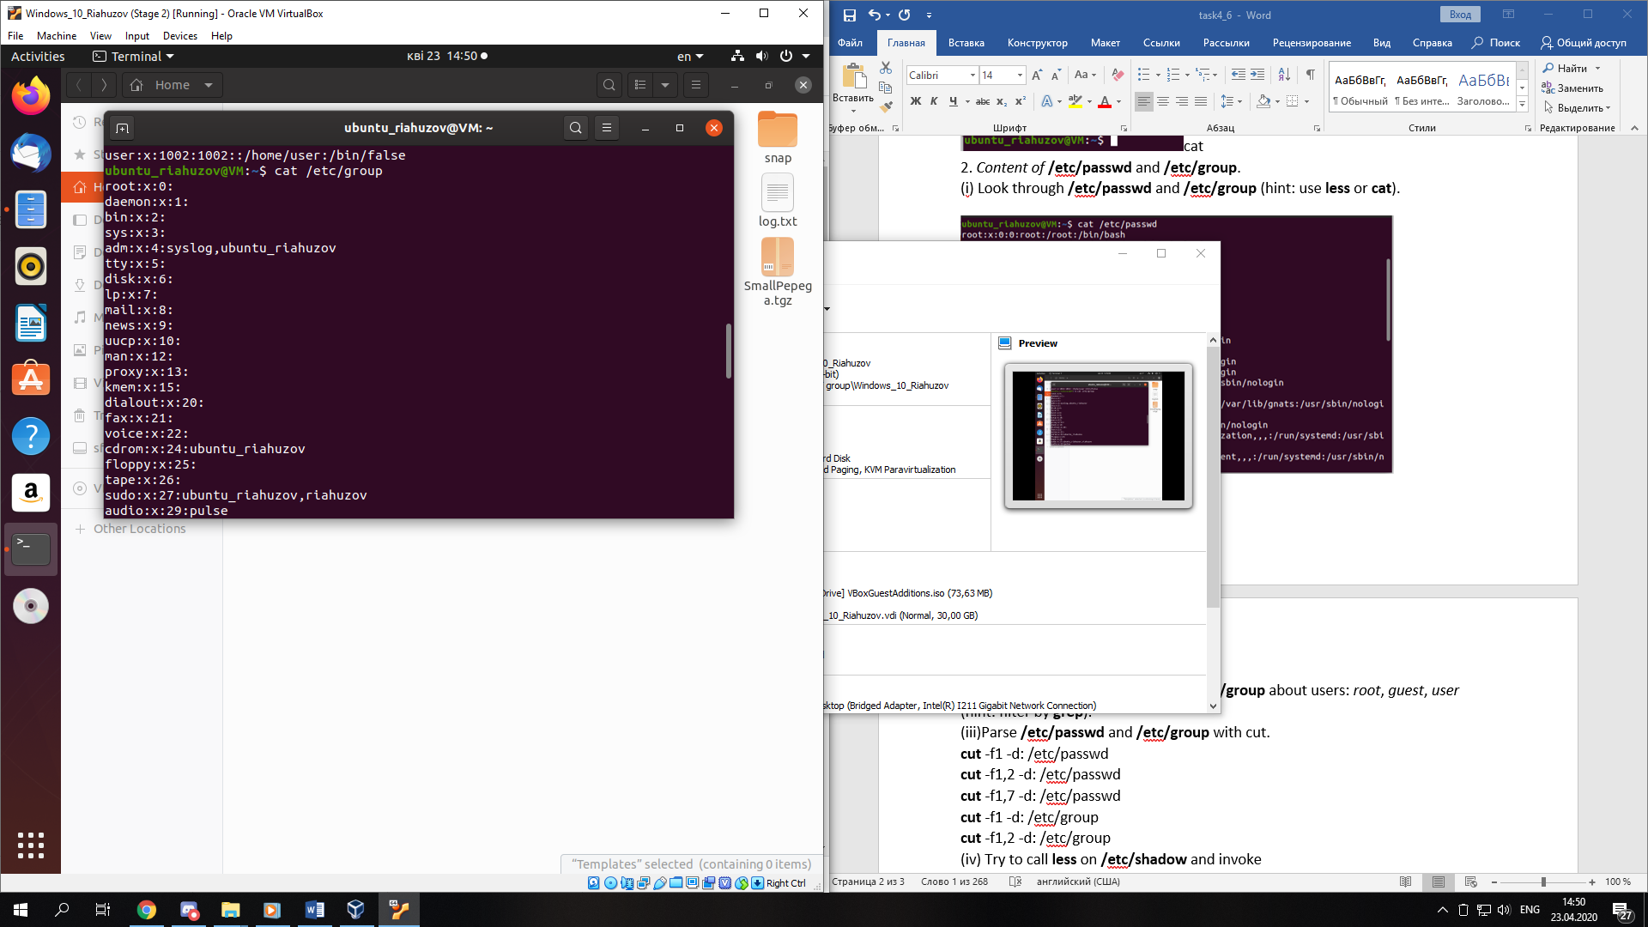

(ii) Get data from /etc/passwd and /etc/group about users: root, guest, user (hint: filter by grep).

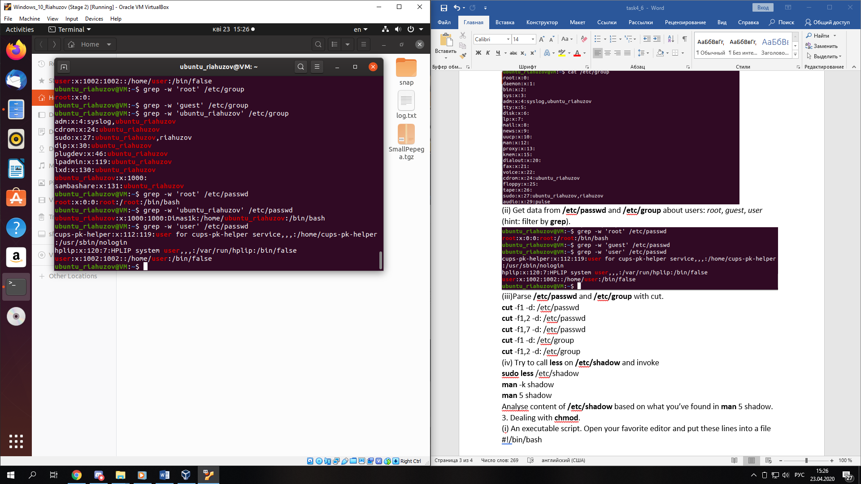

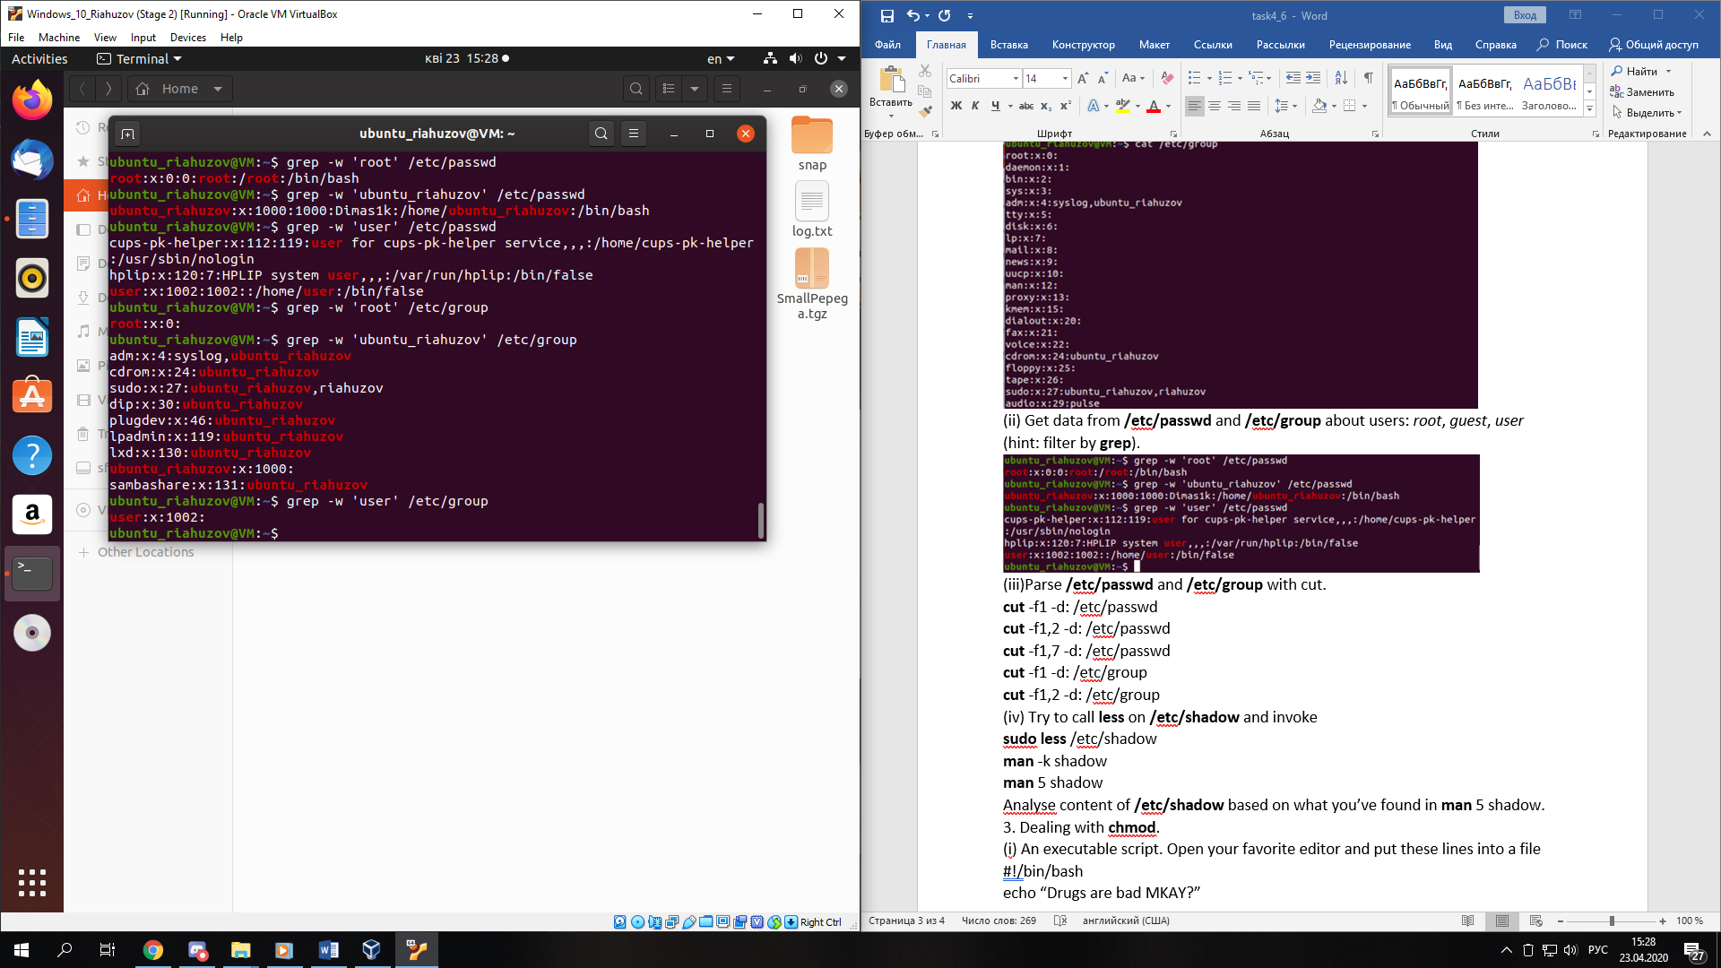

(iii)Parse /etc/passwd and /etc/group with cut.

cut -f1 -d: /etc/passwd

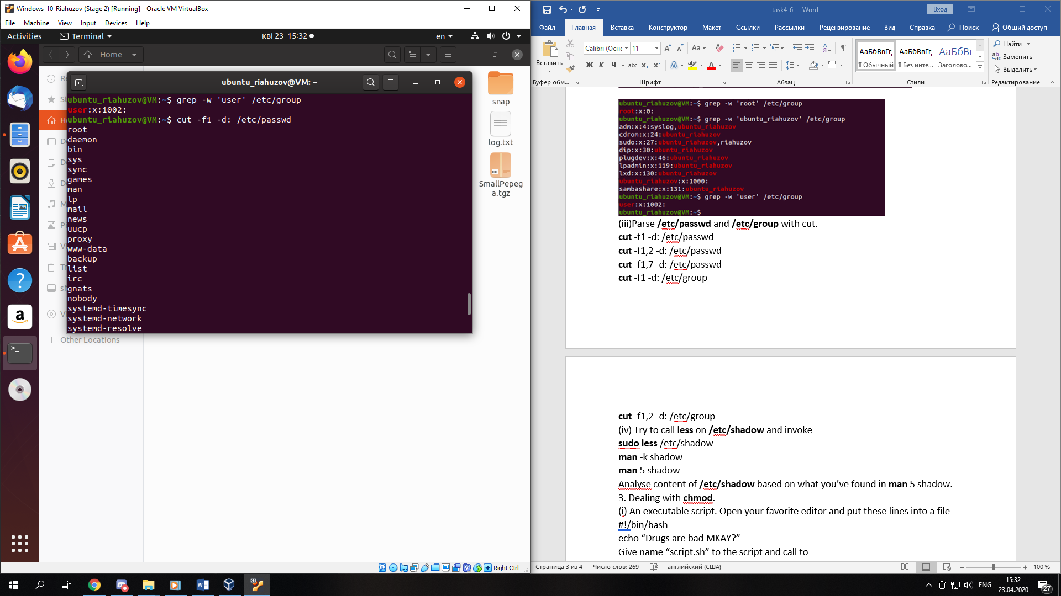

cut -f1,2 -d: /etc/passwd

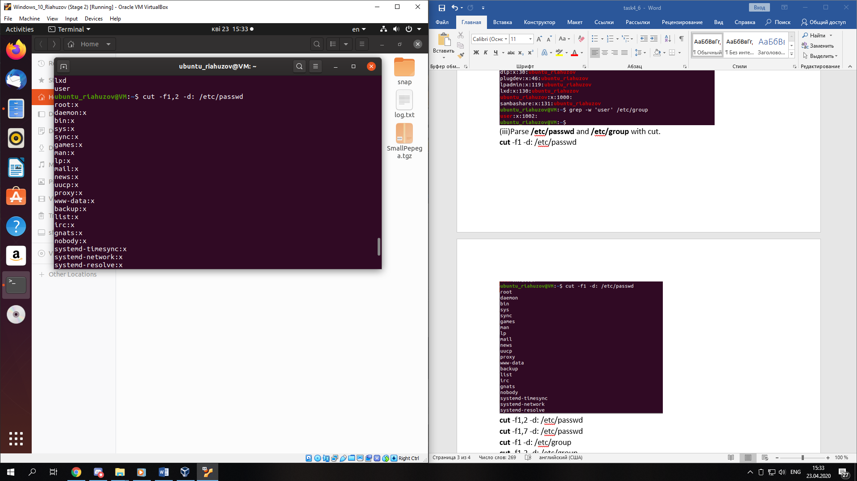

cut -f1,7 -d: /etc/passwd

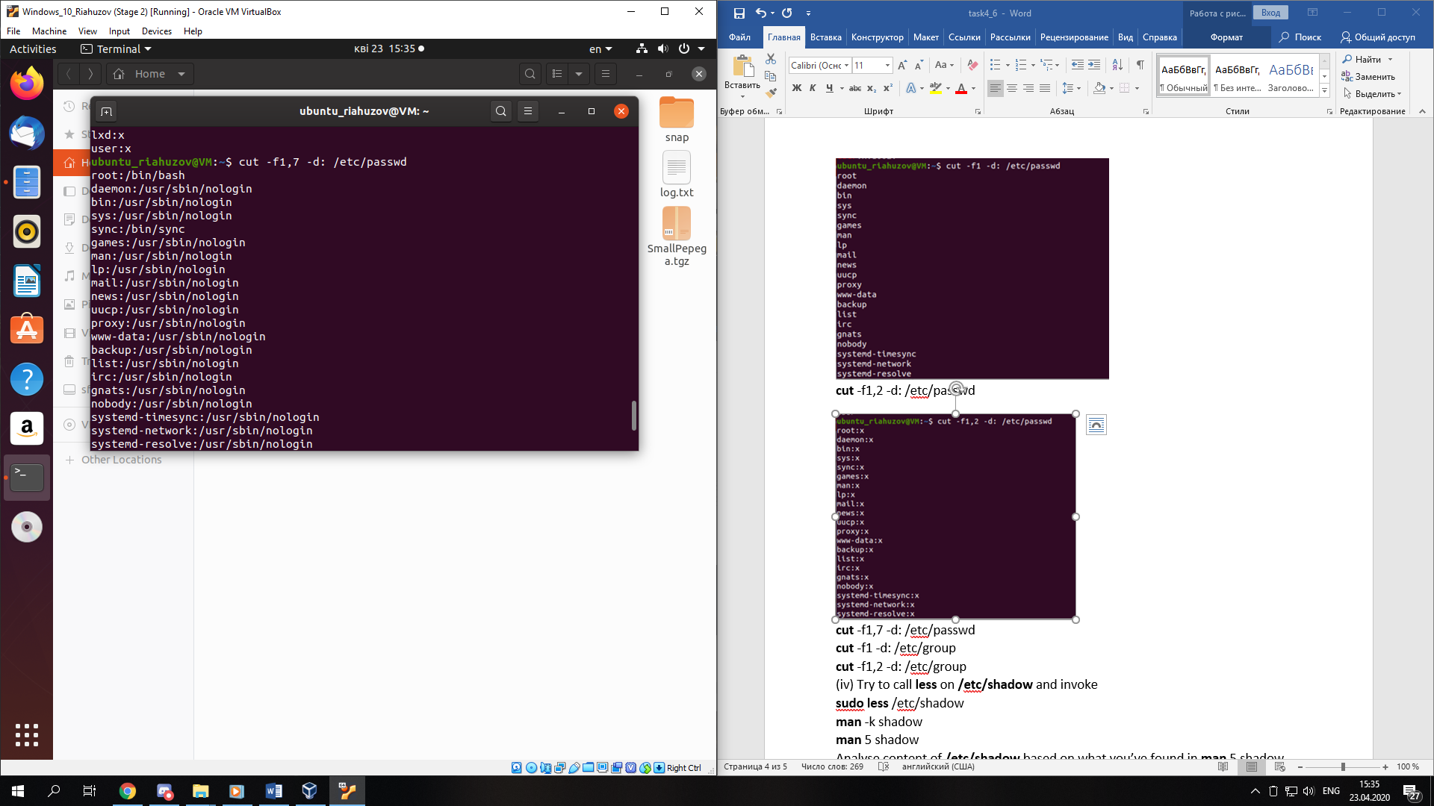

cut -f1 -d: /etc/group

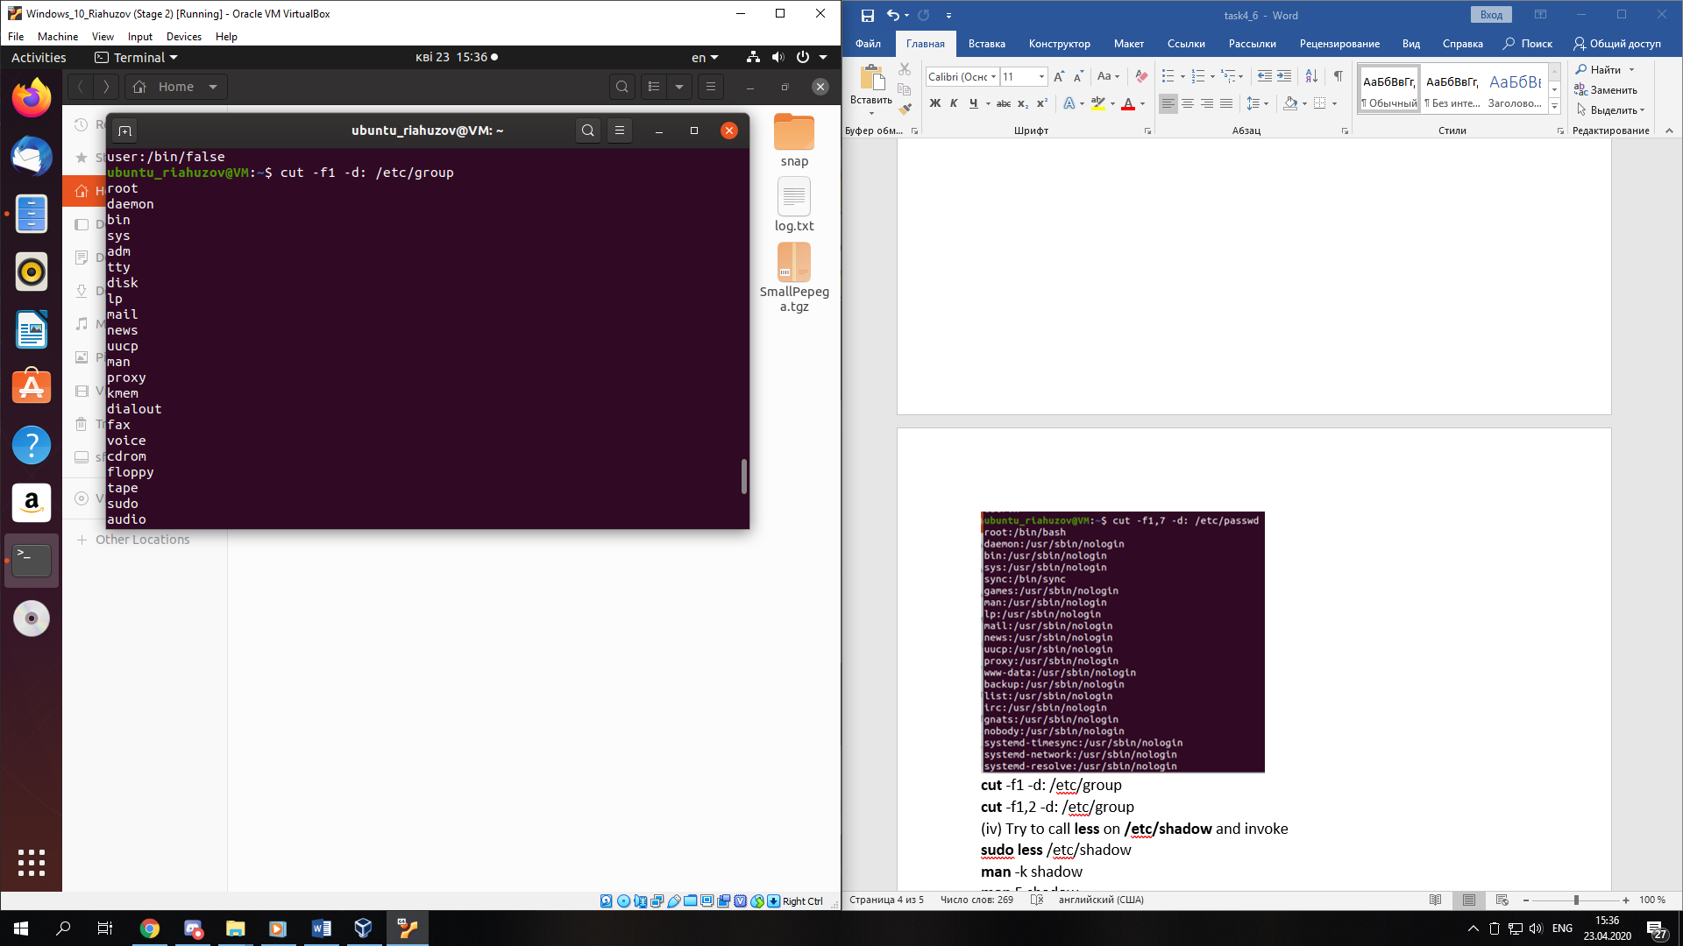

cut -f1,2 -d: /etc/group

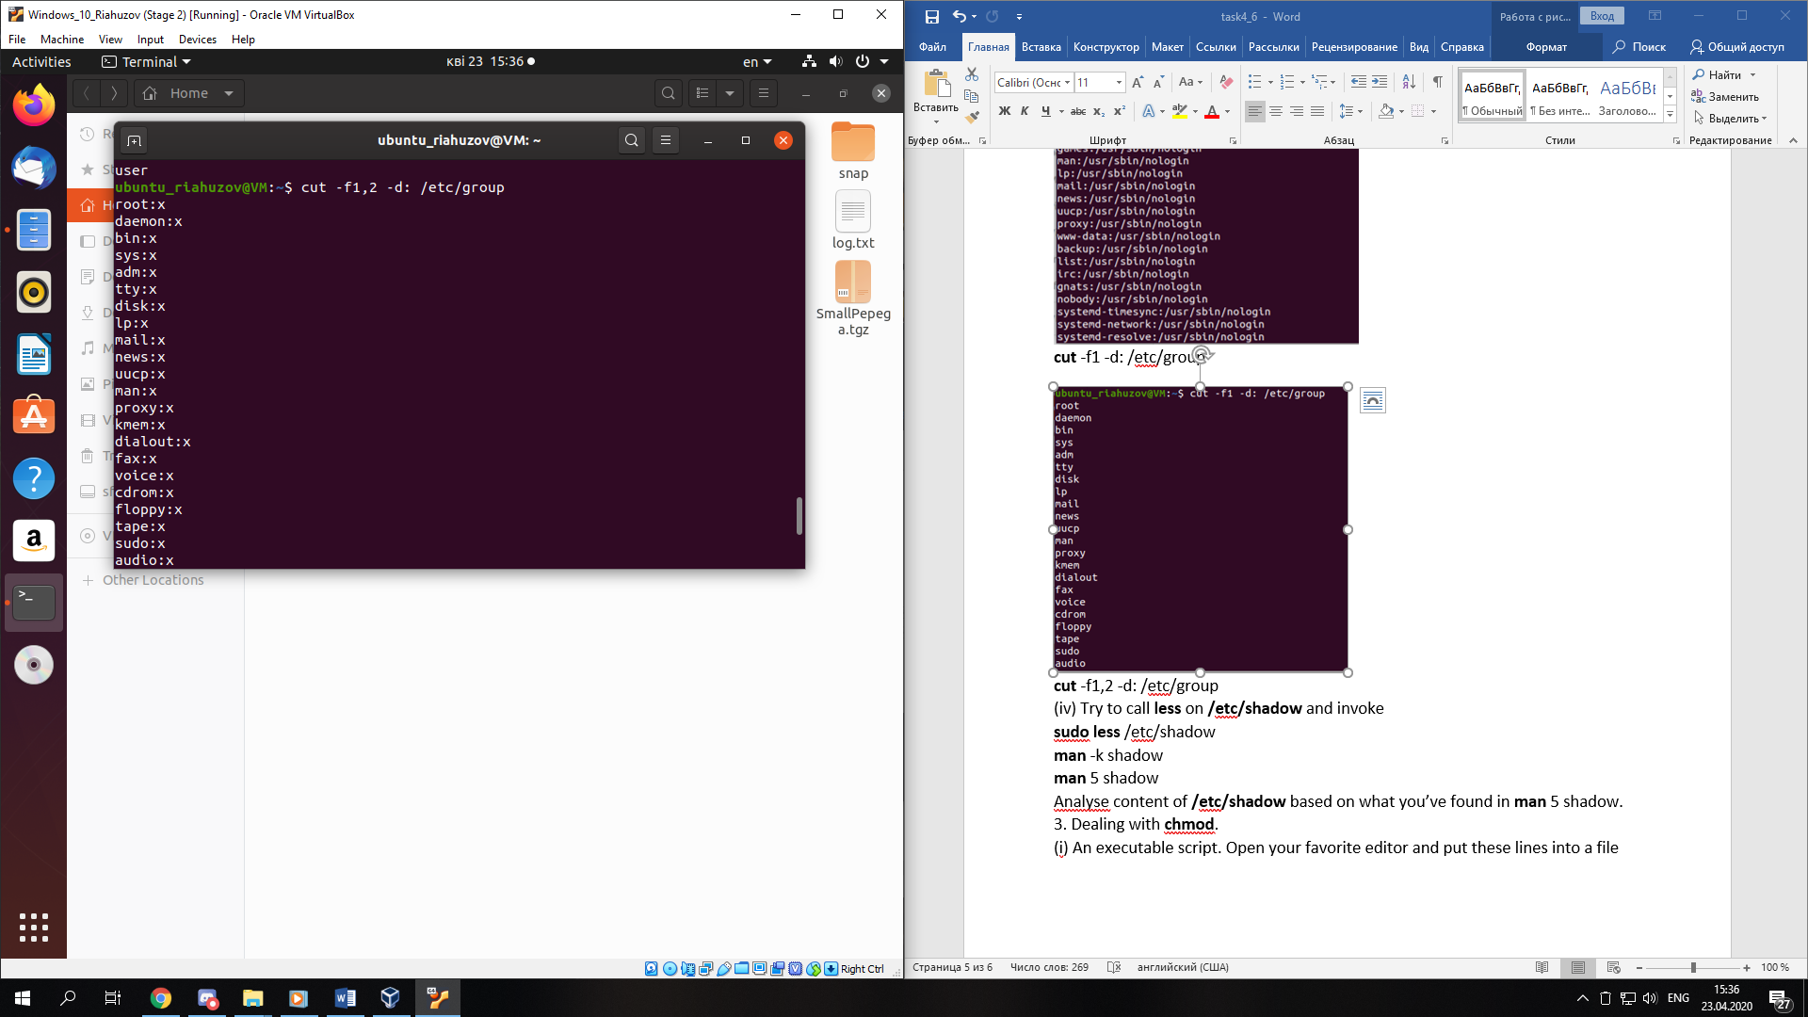

(iv) Try to call less on /etc/shadow and invoke

sudo less /etc/shadow

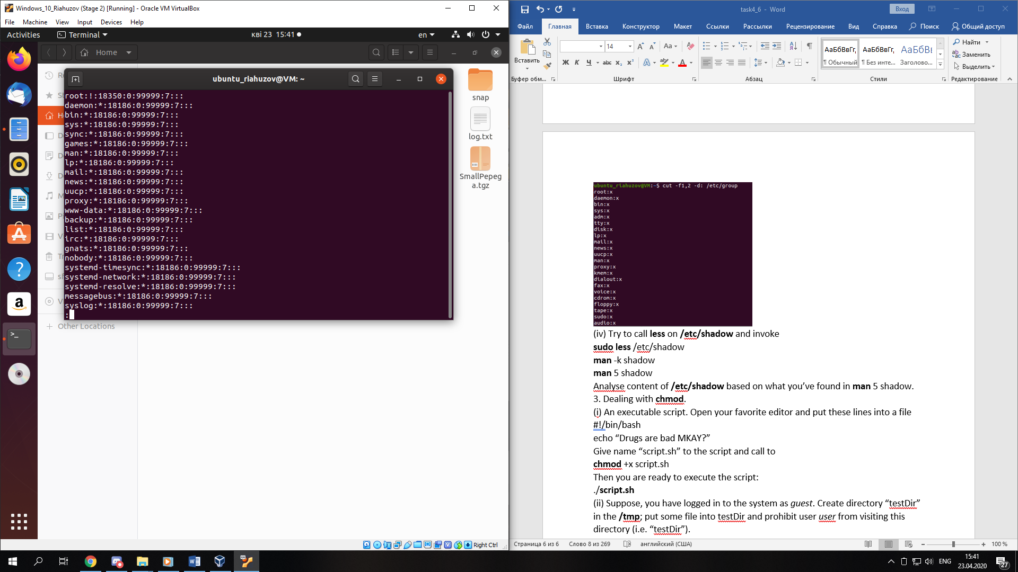

man -k shadow

man 5 shadow

Analyse content of /etc/shadow based on what you’ve found in man 5 shadow.

*Each line of this file contains 9 fields, separated by colons (:), in the following order:* ***login name****(valid account name),* ***encrypted password*** *(for instance ! or *, the user will not be able to use a unix password to log in, this field may be empty, in which case no passwords are required to authenticate as the specified login name ),* ***date of last password change*** *(the date of the last password change, expressed as the number of days since Jan 1, 1970),* ***minimum password age****(is the number of days the user will have to wait before he will be allowed to change his password again ),* ***maximum password age*** *(is the number of days after which the user will have to change her password),* ***password warning period*** *(the number of days before a password is going to expire during which the user should be warned),* ***password inactivity period*** *(the number of days after a password has expired during which the password should still be accepted),* ***account expiration date****(the date of expiration of the account, expressed as the number of days since Jan 1, 1970),* ***reserved field*** *(this field is reserved for future use).*

3. Dealing with chmod.

(i) An executable script. Open your favorite editor and put these lines into a file

#!/bin/bash

echo “Drugs are bad MKAY?”

Give name “script.sh” to the script and call to

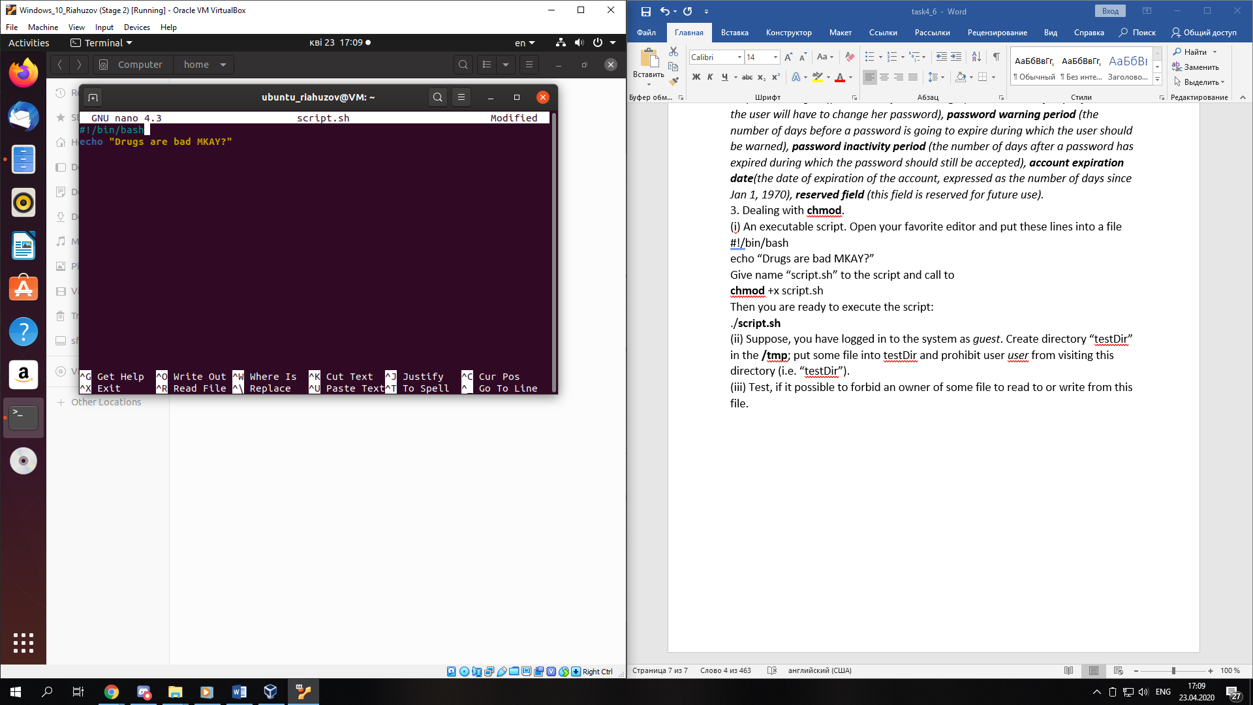

chmod +x script.sh

Then you are ready to execute the script:

./script.sh

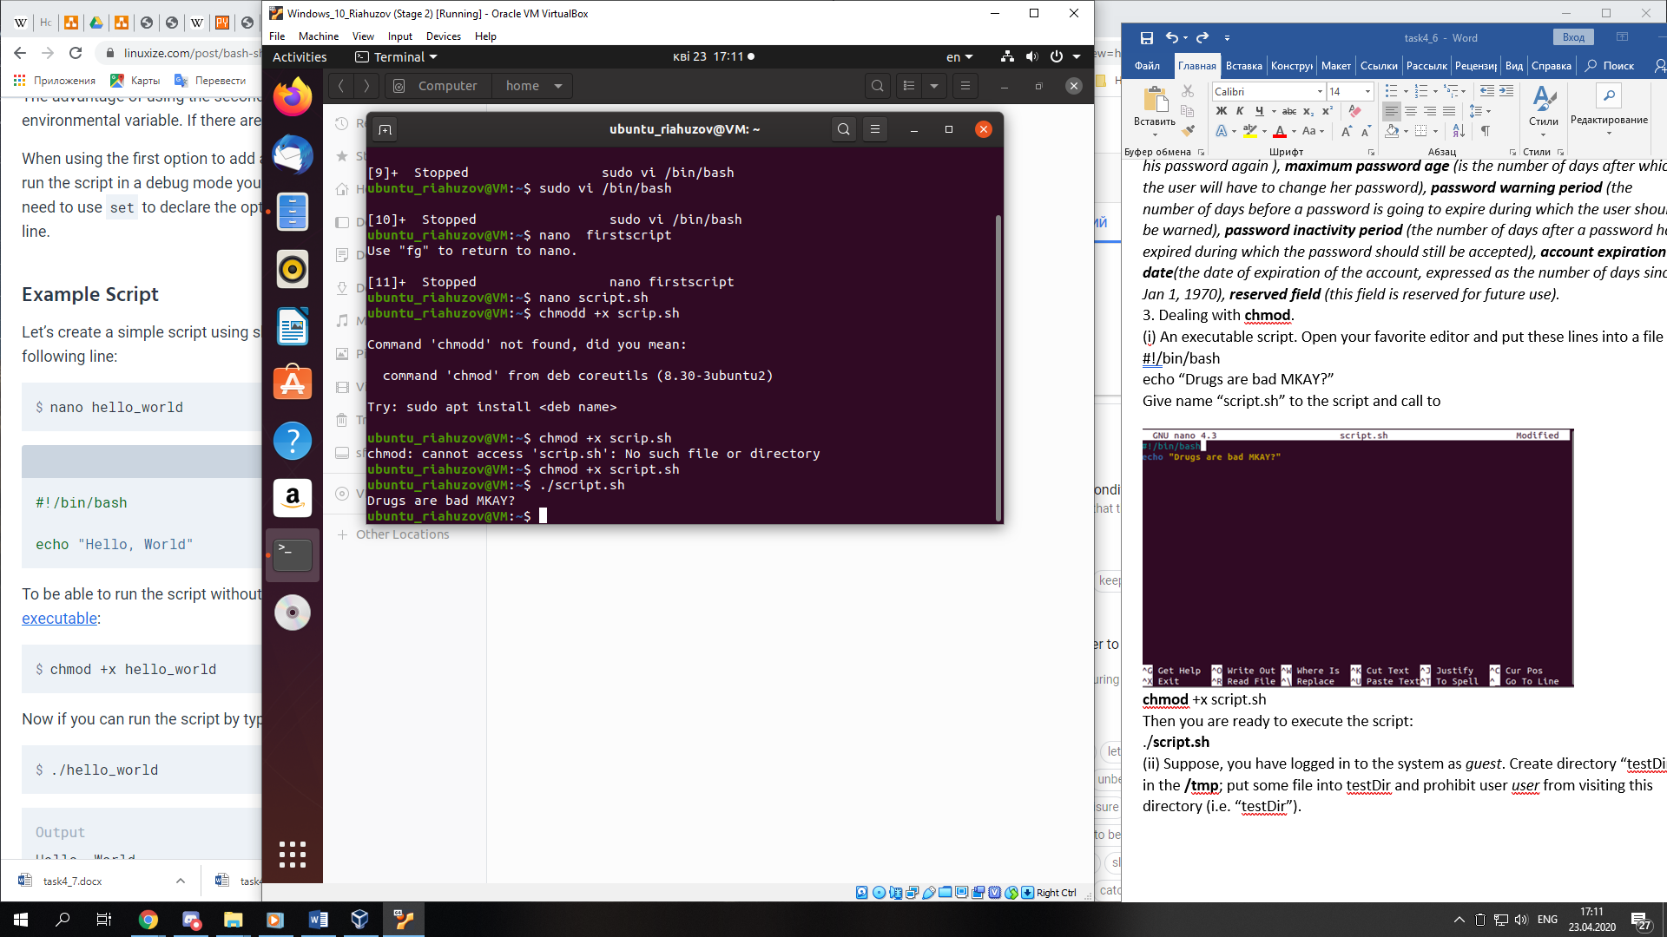

(ii) Suppose, you have logged in to the system as guest. Create directory “testDir” in the /tmp; put some file into testDir and prohibit user user from visiting this directory (i.e. “testDir”).

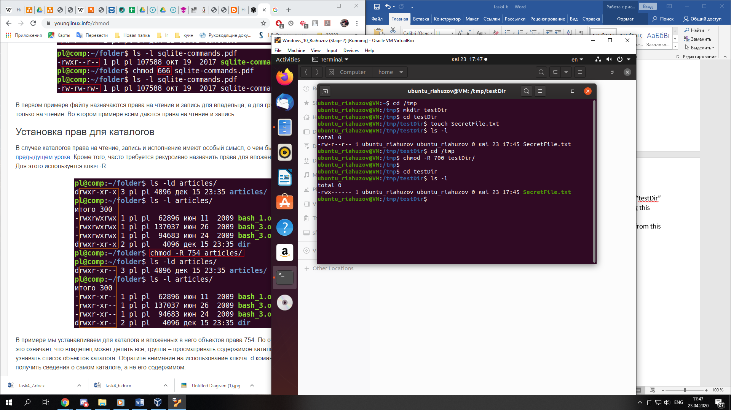

(iii) Test, if it possible to forbid an owner of some file to read to or write from this file.

